Feedback Control System Design of Buck Converter

1. Feedback Control Design First Look

In this section, the design of controller system of Buck Converter (DC-DC) is implemented via schematics.

(output reference)

**system input**

y

error

yref

u

output

e

**-**

**+**

GP(s)

GC(s)

Plant System

Controller

Fig. Feedback Control System Schematic

There are 3 steps to modeling the Plant ( GP(s) )

1. Model the dynamic states
2. Simplify & linearize the system
3. Find the transfer function
4. Modeling the Plant System Gp(s)

**iO**

**iL**

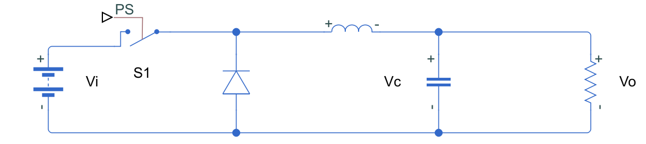

Fig. 1 Buck Converter

$$Switch S_{1} is ON$$

$$V_{L} = V_{İ}-V_{O}$$

$$Switch S_{1} is OFF$$

$$V_{L} = -V_{O}$$

$$D = \frac{t_{ON}}{T} = \frac{t_{ON}}{t_{ON}+t_{OFF}}$$

How to derive switching circuit into a plant system?

We always start with the dynamic states. Dynamic states are just components that are governed by an equation that has a derivative.

If we look at the schematic for the buck converter above, the two components are governed by differential equations are ‘’Inductor and Capacitor’’.

$$Inductor Current = \frac{di_{L}}{dt} = \frac{1}{L}\left[\left(V_{i}-V_{C}\right)D+\left({-V}_{C}\right)(1-D)\right]$$

$$Capacitor Voltage =\frac{dV_{C}}{dt} = \frac{1}{C}\left[\left(i_{L}-\frac{V_{C}}{R}\right)D+\left(i_{L}-\frac{V_{C}}{R}\right)(1-D)\right]$$

$$Inductor Current = \frac{di_{L}}{dt} = \frac{1}{L}\left[V_{i}D - V_{C}D - V_{C}+V_{C}D)\right]$$

$$\frac{di_{L}}{dt} = \frac{V_{i}}{L}D - \frac{V_{C}}{L}$$

$$Capacitor Voltage =\frac{dV_{C}}{dt} = \frac{1}{C}\left[İ_{L}D -\frac{V_{C}}{R}D+İ_{L} - İ_{L}D -\frac{V_{C}}{R}+\frac{V_{C}}{R}D\right]$$

$$\frac{dV_{C}}{dt} = \frac{1}{C}\left[İ_{L} - \frac{V_{C}}{R} \right]$$

$$\frac{dV_{C}}{dt} = \frac{İ_{L}}{C} - \frac{V_{C}}{RC}$$

1. Simplify & Linearize the System

Inductor Current Capacitor Voltage

$\frac{di_{L}}{dt} = - \frac{V_{C}}{L}+$ $\frac{V_{i}}{L}D$ $\frac{dV_{C}}{dt}=\frac{İ_{L}}{C} - \frac{V_{C}}{RC}$

New Variables:

y

output

States

(X1,X2,X3….)

u

system input

x1 D = u

x2 y = VC = x2

State Equations

x1 D = u

x2 y = VC = x2

(

(

1. Find the Transfer Function

We use Laplace Transform & rearrange the terms.

Input = u $T(s) = \frac{y(s)}{u(s)}$

Output = y = x2

Consider x2 = Y

This was our transfer function of GP(s) plant system.

1. Modeling the Controller System GC(s)

$$PID: G_{c}(s)=K_{P}+K_{i}\frac{1}{s}+K_{D}s (transfer function for PID controller)$$

Multiply PID equation by $\frac{s}{s}$

$$G_{c}(s)=\left(K_{P}+K_{i}\frac{1}{s}+K_{D}s\right).\frac{s}{s}$$

$$G_{c}(s)=\frac{\left(K_{D}s^{2}+K_{P}s+K_{i}\right)}{s}$$

Our total transfer function for the system

$$TF=\frac{Y(s)}{Y_{ref}(s)}= \frac{{G_{p}(s)G}_{c}(s)}{1+{G_{p}(s)G}_{c}(s)}$$

$G_{p}(s)$ was calculated in previous page. Put into the above equation:

$$\frac{Y(s)}{Y_{ref}(s)}= \frac{{\frac{\frac{V_{i}}{LC}}{s^{2}+\frac{1}{RC}s+\frac{1}{LC}}G}_{c}(s)}{1+{\frac{\frac{V_{i}}{LC}}{s^{2}+\frac{1}{RC}s+\frac{1}{LC}}G}_{c}(s)}$$

$$TF: \frac{Y(s)}{Y_{ref}(s)}=\frac{\frac{V_{i}}{LC}G_{c}(s)}{s^{2}+\frac{1}{RC}s+\frac{1}{LC}+\frac{V_{i}}{LC}G_{c}(s)}$$

$$G_{c}(s)=\left(\frac{K_{D}s^{2}+K_{P}s+K_{i}}{s}\right)$$

Put $G_{c}(s)$ eq. into TF eq.

$$=\frac{\frac{V_{i}}{LC}\left(\frac{K_{D}s^{2}+K_{P}s+K_{i}}{s}\right)}{s^{2}+\frac{1}{RC}s+\frac{1}{LC}+\frac{V_{i}}{LC}\left(\frac{K_{D}s^{2}+K_{P}s+K_{i}}{s}\right)} x \frac{s}{s} (to simplify)$$

$$\frac{Y(s)}{Y_{ref}(s)}=\frac{\frac{V_{i}}{LC}K_{D}s^{2}+\frac{V_{i}}{LC}K_{P}s+{\frac{V_{i}}{LC}K}_{i}}{s^{3}+\left(\frac{1}{RC}+\frac{V_{i}}{LC}K_{D}\right)s^{2}+\left(\frac{1}{LC}+\frac{V_{i}}{LC}K_{P}\right)s+{\frac{V_{i}}{LC}K}_{i}}$$

It can be observed from denumerator, the system is having $3^{rd}$ order equation that means it has 3 poles.

Performance Characteristics:

1. Stability
2. Rise time, Overshoot, Settling Time